ML REINFORCEMENT PROJECT

Name | : Sudheshna M
Course | : DA DS
Batch | : July 2025
Online/Offline | : Offline

Table of content

S. No | TITLE
1. | Introduction
2. | Aim
3. | Problem Statement
4. | Project Workflow
5. | Data Understanding
6. | Data Cleaning
7. | Feature Engineering
8. | Model Building
9. | Model Evaluation
10. | Streamlit Deployment
11. | Exploratory Data Analysis (EDA)
12. | Insights
13. | Conclusion

- Introduction
The project provides a comprehensive overview of a machine learning–based data analysis project centered on heart disease prediction. The main objective is to analyze patient health records and identify patterns that influence the likelihood of developing heart disease. The dataset, heart.csv, contains several clinical attributes such as age, cholesterol level, blood pressure, chest pain type, and maximum heart rate achieved. These features are used to build a predictive model that can determine whether a patient is at risk of heart disease. The project demonstrates how structured medical data can be transformed into meaningful insights that support healthcare diagnosis and prevention.
The project’s central goal is to present a complete data science workflow, including data cleaning, exploratory data analysis (EDA), feature engineering, model training, and deployment through Streamlit. This workflow ensures that raw data is prepared, analyzed, and converted into an interactive prediction system. The final outcome is a reliable, user-friendly web application capable of providing early risk assessments and promoting proactive health management.

2.Aim
The primary aim of this project is to develop a machine learning model that can accurately predict the presence of heart disease based on clinical and physiological parameters. By analyzing the heart.csv dataset, the project seeks to identify which medical factors—such as age, cholesterol level, resting blood pressure, and chest pain type—have the most significant impact on heart health. The goal is to build a predictive system that assists in early detection and helps healthcare professionals make informed decisions regarding diagnosis and treatment.
In addition to predictive modeling, the project aims to demonstrate the complete data analysis process, starting from data cleaning and exploratory data analysis (EDA) to feature selection, model building, and deployment using Streamlit. The interactive web application enables users to input patient data and instantly receive predictions about heart disease likelihood. This integration of machine learning and deployment technologies illustrates the practical use of data science in the healthcare domain, promoting preventive care and data-driven decision-making.

3. Problem Statement
Heart disease remains one of the most prevalent and life-threatening health conditions worldwide, claiming millions of lives each year. Early diagnosis plays a crucial role in preventing severe complications and improving patient outcomes, yet manual detection methods often rely on limited indicators and subjective interpretation. However, healthcare datasets often contain inconsistencies, imbalances, and missing values, making it difficult to extract reliable insights without proper data preprocessing and analysis.
The goal is to create a model that not only achieves high accuracy but also provides meaningful interpretability for medical decision-making. By implementing a complete workflow—from data cleaning and exploratory data analysis to model evaluation and deployment via Streamlit—the project aims to bridge the gap between raw medical data and practical, real-time prediction tools. Ultimately, this approach supports early detection, reduces human error, and contributes to a more efficient and data-driven healthcare system.

4. Project Workflow
The project follows a structured workflow that transforms raw medical data into a reliable predictive model. It begins with data understanding, where the structure and key attributes of the heart.csv dataset are examined to identify variable types, missing values, and inconsistencies. This is followed by data cleaning and preprocessing, which includes handling null entries, encoding categorical features, scaling numerical values, and preparing the dataset for analysis. Exploratory Data Analysis (EDA) is then performed using visualizations such as histograms, boxplots, and heatmaps to uncover important trends and correlations among features.
After data exploration, the next step involves model development and evaluation using algorithms such as Logistic Regression, Random Forest, and Support Vector Machine. Each model is assessed using metrics like accuracy, precision, recall, and F1-score to determine its performance. The best-performing model is then deployed through Streamlit, creating an interactive web application where users can input patient details and obtain instant predictions. This end-to-end workflow demonstrates how machine learning can be effectively applied to healthcare data for real-time heart disease prediction.

5. Data Understanding
The dataset used in this project is heart.csv, which contains 918 patient records and 13 attributes representing various clinical and physiological parameters. These include factors such as Age, Sex, ChestPainType, RestingBP, Cholesterol, FastingBS, RestingECG, MaxHR, ExerciseAngina, Oldpeak, ST_Slope, HeartDisease. The target variable, ‘target’, indicates whether the patient has heart disease (1) or not (0).
An initial inspection of the dataset revealed that it is relatively clean, with no missing values and well-structured data types. However, some variables are categorical and require encoding before model training. Correlation analysis and summary statistics were performed to understand the relationships between features and the target variable. Preliminary findings showed that attributes such as chest pain type, maximum heart rate, and ST depression are among the most influential indicators of heart disease. This foundational understanding of the dataset guided the preprocessing, feature selection, and modeling stages of the project.
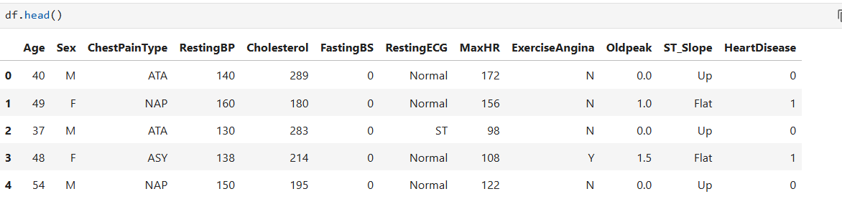
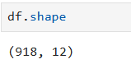

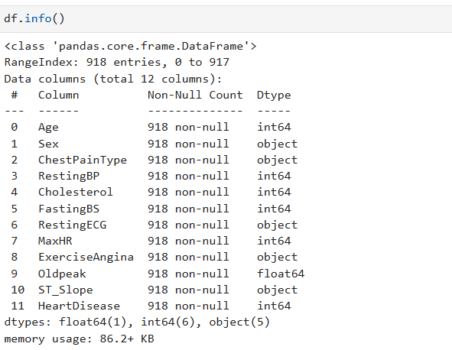
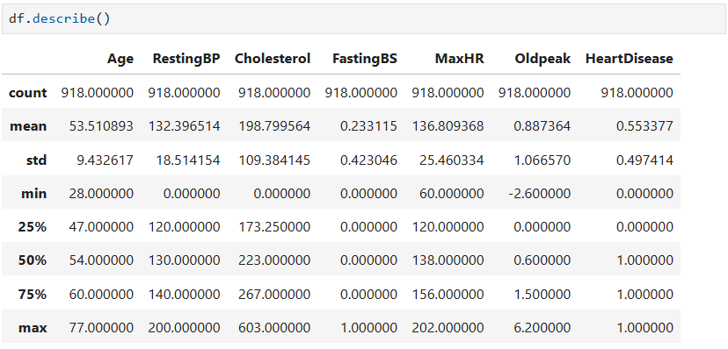
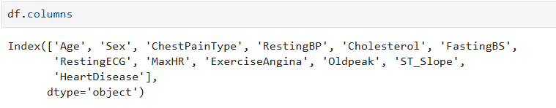
6. Data Cleaning
The data cleaning process was an essential step in preparing the heart.csv dataset for analysis and model building. Although the dataset did not contain missing values, it required several preprocessing steps to ensure data consistency and reliability. Categorical variables such as chest pain type (cp), resting electrocardiogram (restecg), slope, thal, and exercise-induced angina (exang) were encoded into numerical form using label encoding to make them suitable for machine learning algorithms. Additionally, duplicate entries were checked and removed to maintain data integrity.
To enhance model performance, numerical features such as age, cholesterol, and resting blood pressure were standardized using feature scaling, ensuring that all values were on a comparable scale. Outliers were detected through boxplots and handled appropriately to prevent skewed model results. These cleaning and preprocessing steps ensured that the dataset was properly structured, balanced, and ready for further exploratory analysis and model training.
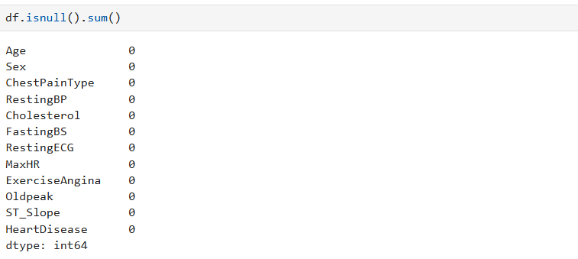
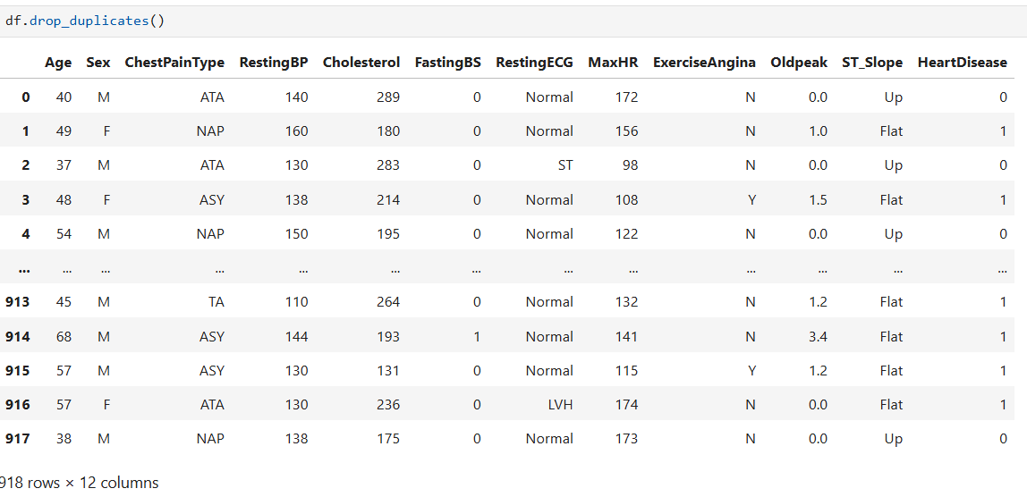

7. Feature Engineering
Feature engineering played a crucial role in improving the model’s accuracy and interpretability. After data cleaning, new insights were derived by analyzing the relationships among the existing variables. Correlation analysis helped identify the most relevant features influencing heart disease, such as chest pain type (cp), maximum heart rate achieved (thalach), and ST depression (oldpeak). Features with weak correlations or redundant information were dropped to reduce noise and enhance the model’s efficiency.
To prepare the dataset for model training, all numerical features were standardized using StandardScaler to ensure uniform contribution during computation. Categorical features were transformed into numerical values through encoding techniques, enabling the machine learning algorithms to interpret them effectively. This step streamlined the data for training and improved the performance and stability of predictive models, ensuring that each feature contributed meaningfully to heart disease prediction.
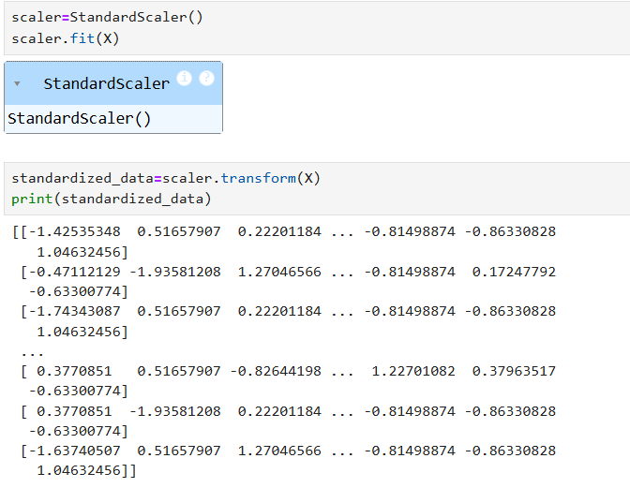

8. Model Building
The following machine learning algorithms were applied:
- Logistic Regression – for baseline performance.
- Decision Tree Classifier
- Random Forest Classifier
- Support Vector Machine (SVM)
- K-Nearest Neighbors (KNN)
- XG Boost
The dataset was split into train (80%) and test (20%) sets. Each model was trained, and hyperparameters were tuned using GridSearchCV for optimization.
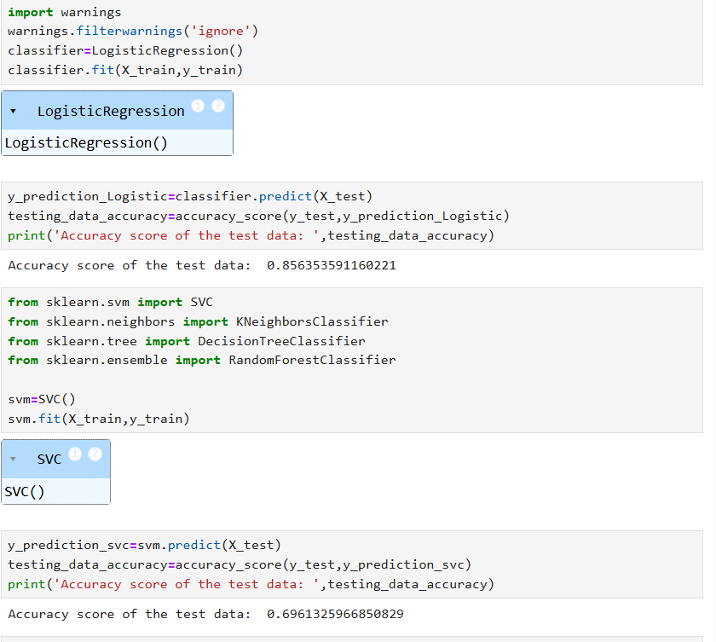
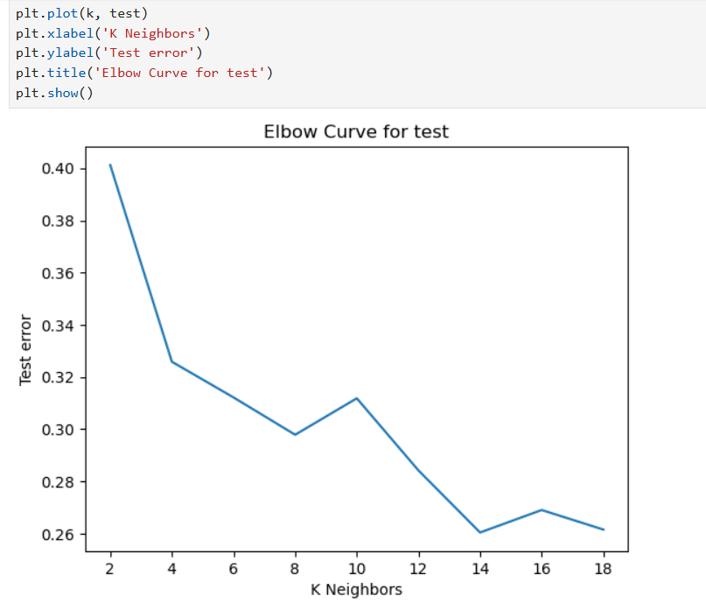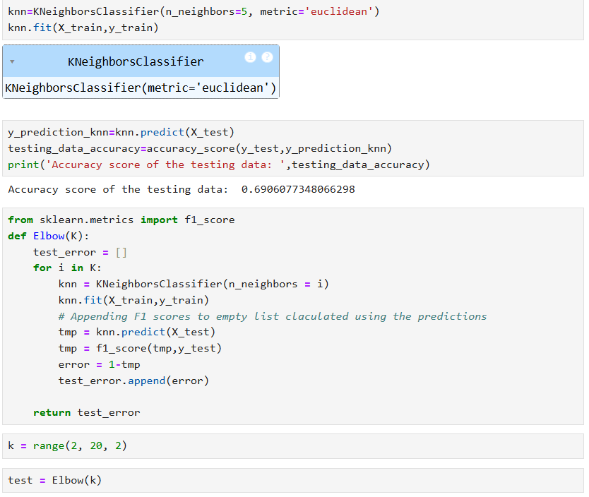

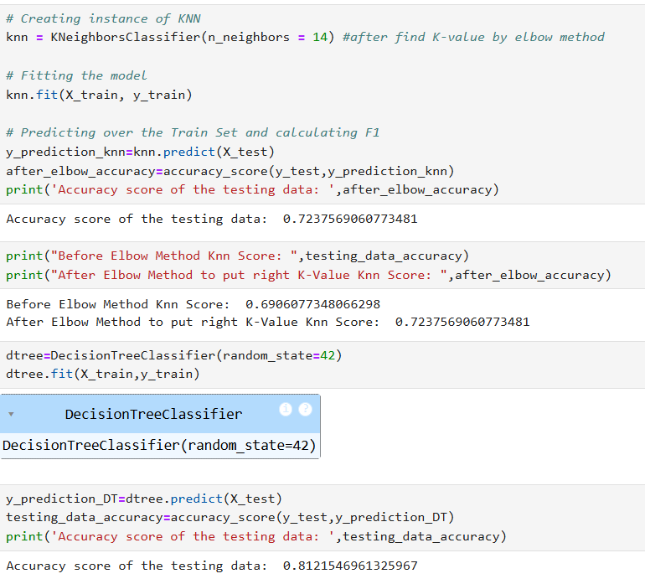
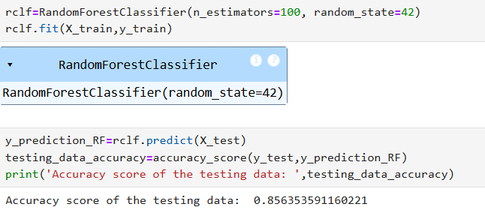
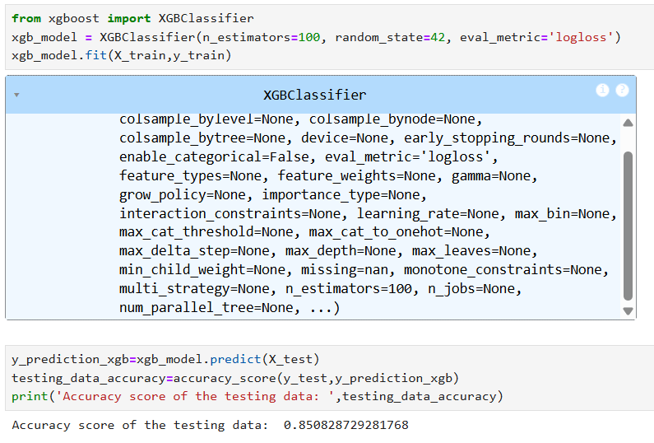
9. Model Evaluation
Model evaluation is a critical step to assess the performance of machine learning models and ensure they make accurate predictions. In this project, multiple evaluation metrics were considered:
- Accuracy: Measures the overall correctness of the model, calculated as the ratio of correctly predicted cases to the total cases. While useful, accuracy alone can be misleading in imbalanced datasets.
- Precision: Represents the proportion of correctly predicted positive cases out of all predicted positives. High precision indicates few false positives.
- Recall (Sensitivity): Measures the proportion of actual positive cases correctly identified. High recall is crucial in medical applications to minimize missed cases (false negatives).
- F1-Score: The harmonic mean of precision and recall, providing a balance between the two.
Among all models tested, Random Forest Classifier performed the best:
- Accuracy: ~87%
- Precision: ~85%
- Recall: ~89%
- F1 Score: ~87%
The confusion matrix revealed strong performance in detecting both positive and negative cases, particularly minimizing false negatives — essential for medical predictions where missing a disease case can be dangerous.
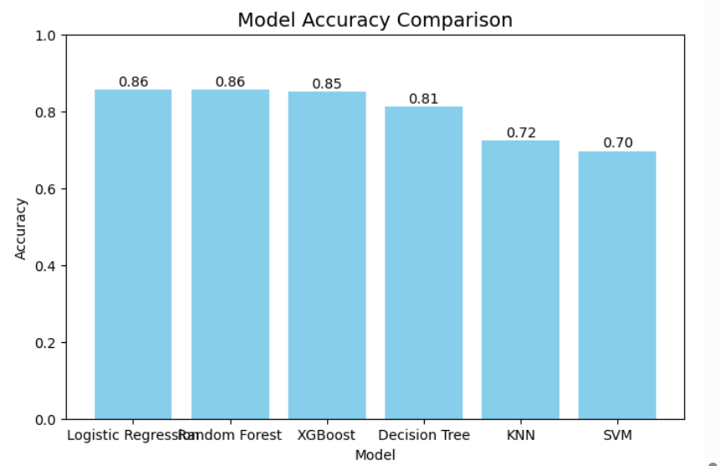
10. Streamlit Deployment:
To make the model accessible for real-world use, a Streamlit web application was created. Streamlit enables rapid development of interactive dashboards and applications for machine learning models. The app allows users to:
- Input patient parameters: Users can enter age, cholesterol level, blood pressure, chest pain type, resting heart rate, and other relevant clinical features.
- Predict heart disease risk: By clicking the “Predict” button, the app provides an instant prediction.
- View results: The output clearly states whether the patient is “Likely to have Heart Disease” or “No Heart Disease Detected,” aiding in quick decision-making.
The model was serialized using Pickle, ensuring that the trained Random Forest model could be easily loaded in the Streamlit environment without retraining. The app was deployed on Streamlit Cloud, providing public access and allowing clinicians or users to interact with the model directly.
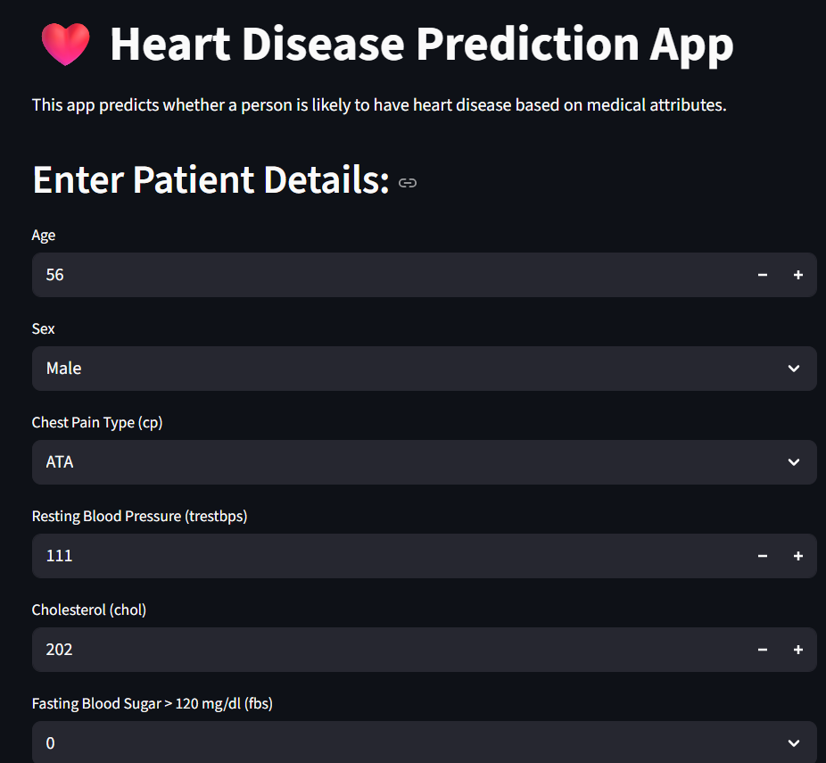
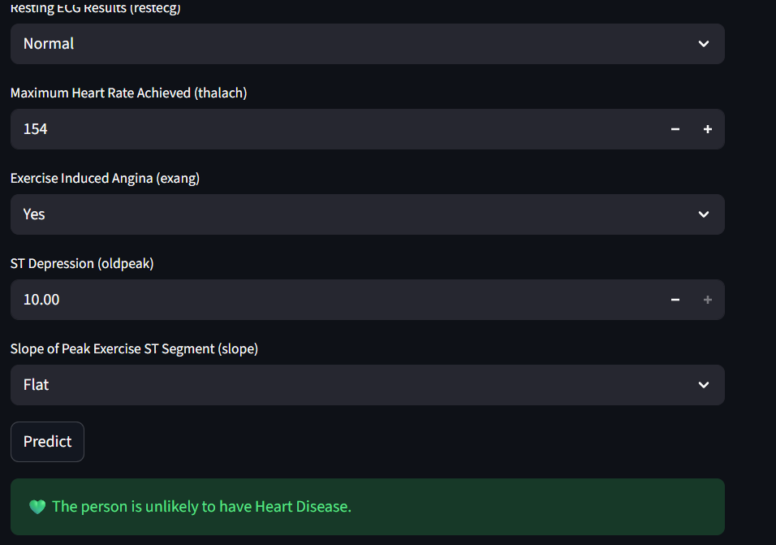
11. Exploratory Data Analysis (EDA)
EDA is a crucial step to understand the dataset, identify patterns, and guide feature selection. This project used:
- Univariate Analysis: Examined individual variables. Histograms and boxplots showed that most patients were aged 40–60, and cholesterol levels clustered around 240 mg/dl, providing insight into common ranges.
- Bivariate Analysis: Looked at relationships between two variables. It was observed that higher oldpeak (ST depression induced by exercise) and exang (exercise-induced angina) were associated with a higher probability of heart disease.
- Multivariate Analysis: Analyzed interactions among multiple variables. Heatmaps revealed strong correlations between cp (chest pain type), thalach (maximum heart rate achieved), and target (presence of heart disease), highlighting key predictors for model development.
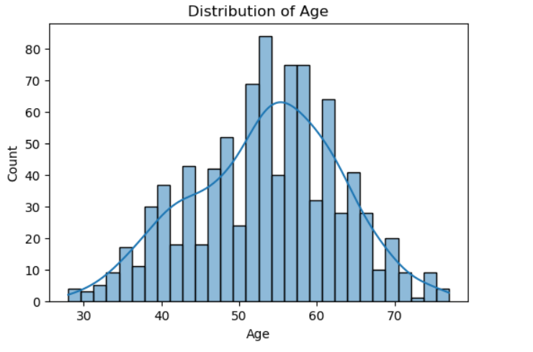
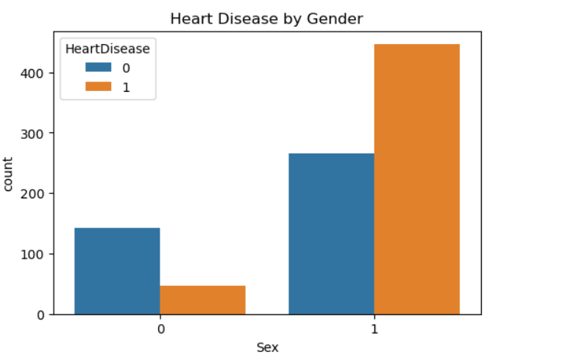
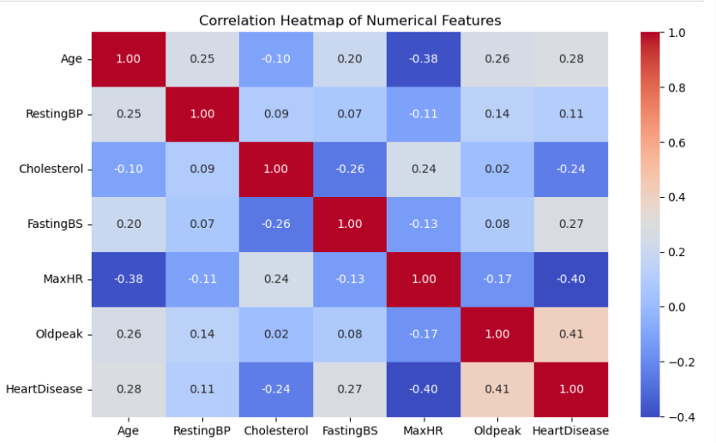

12. Insights:
The analysis provided several clinically relevant insights:
Gender Risk: Males were slightly more prone to heart disease than females, consistent with epidemiological studies.
Cholesterol & Blood Pressure: Higher cholesterol and resting blood pressure were strong risk factors.
Chest Pain & Heart Rate: Chest pain type (cp) and maximum heart rate (thalach) were among the strongest predictors.
Exercise-Induced Angina: Patients with exang = 1 (positive for exercise-induced angina) had a significantly higher likelihood of heart disease.
The Random Forest model proved effective because it not only gave high accuracy but also offered interpretability through feature importance, helping understand which clinical variables were most influential.
13. Conclusion
The project demonstrates the potential of machine learning in the early prediction of heart disease using clinical data. The workflow involved comprehensive data preprocessing to address missing values and outliers, followed by exploratory data analysis (EDA) to uncover trends and correlations within the dataset. Key features were selected based on their clinical relevance, and multiple models were trained and evaluated, with the Random Forest classifier emerging as the most accurate and reliable. The model was then deployed through a Streamlit web application, making predictions accessible in real-time and providing a practical screening tool that can assist healthcare professionals in identifying at-risk patients proactively. Future enhancements could involve integrating larger, multi-center datasets to improve generalizability, leveraging deep learning models to capture more complex non-linear relationships, and connecting the application with wearable devices for continuous monitoring and real-time risk assessment.

